Year 1 Greasby Infant School Knowledge Organiser
Read to Write Unit: Rapunzel | Literacy
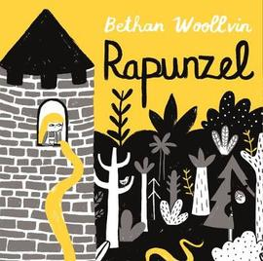 | In this unit the children will be exploring a range of traditional tales with a particular focus upon the story of Rapunzel. They will be sequencing key events and writing simple sentences to re-tell the story in their own words. The children will be learning new, exciting vocabulary, learning about story openers and they will use a range of conjunctions to extend their sentences. At the end of the unit, the children will write a new version of Rapunzel using their own character.
Curriculum Content this half term…
Maths | Science
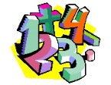  Year 1 will be continuing addition and subraction, within 10. Identifying and naming a range of common 2D and 3D shapes. Reading, writing and ordering numbers to 20. Saying what is 1 more and 1 less than a number between 1 and 20. Solving addition and subtraction problems using a range of apparatus. | Children will be identifying and naming a variety of everyday materails including wood, plastic, glass, metal and rock. They will be investigating and describing their properties, organising them into groups and discovering which materials are the most appropriate for use based on their properties.
History | Geography
Children will be learning about their grandparents’ school days and talking about the similarities and differences. Children will talk about the ‘past’ and ‘present’ and will be able to order pictures along a timeline. | In Geography, children will be able to tell the difference between a town, village and a city. They will look at aerial maps and talk about common features; man-made and physical.
RE | PE
On the run up to Christmas, children will be talking about what gifts Christians might have given to Jesus, if he was born here rather than in Bethlehem. Children will learn about the Christmas story and understand why Christmas is celebrated around the world. | Dance  Children will be continuing to explore different ways to move their bodies and responding to a variety of stimuli. Moving expressively, confidently and safely in space. Using a variety of speed, level and direction. Children will create and repeat short routines.
Art | DT
Children will be creating a setting/scenery for one of our main characters from Rapunzel. Using drawing and painting to develop ideas and imagination. Developing a range of art and design techniques using colour, pattern, texture, line, shape, form and space. | Designing and making a tower for Rapunzel with a moving part. Considering the best materials to use for the project and what tools and resourses need will be needed. Evaluating ideas by thinking about what worked well and what they would change if they did it again.
Computing | Music
The children will continue to develop their understanding of technology and how it can help them in their everyday lives. They will start to become familiar with the different components of a computer by developing their keyboard and mouse skills. They will also consider how to use technology responsibly. | The children will be listening to new music styles with songs: Rhythm in the way we walk and Banana Rap. They will be learning about the pulse, rhythm and pitch of the music. They will learn to clap the rhythm and play tuned, and un-tuned instruments to the music.
PSHE (Jigsaw)
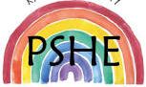
Celebrating Differences

Children will be comparing their own and their friends’ choices and exspressing why some choices are better than others. They will be able to tell us wyas that they are different or similar to other children in the class and why this makes them special. Children will learn about what bullying is and how being bullied might make somebody feel.

