This Week:
This week we have finished our work on the story ‘a River’. The children have learned about a circular story and written their own based on the story using new and interesting language. Next week we will be focusing on the common exception words and revisiting adding the suffix ‘ed’ to a word.

In maths we have been subtracting with renaming (when it crosses the 10s). At the beginning of the week the children used the concrete apparatus and as they became more confident they moved onto using the column method.

Reminders:
Wednesday 18th October – Harvest Assembly (Year 2 parents invited) Please come through the Pre-School door.

Reading | Spelling | Maths
Please encourage your child to read their RWI book at least 3 times a week. This is really important to help develop your child’s fluency (speed of reading).  On our website you will find RWI videos for the sounds your child has been learning in class and videos to match your child’s book to help develop the speed of their reading. These will be updated each week.  Please remember to send your child’s reading books in on a Thursday in the plastic wallet that was provided.  Many thanks | This half term we will be continuing to learn the year 1 common exception words until the children are able to write them confidently. If your child is confident then there are some challenge words below.  house  our  pull  full  there  where | 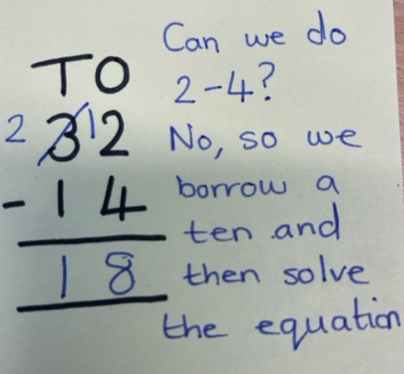  We would like the children to complete the column method sheet which we have sent home. We are focusing on subtraction with renaming. Please see the example below showing how we have taught the children to set it out.  If your child struggles to do 12 – 4 either encourage them to count back from 12 or draw 12 dots and cross out 4.
Challenge Words

took, they, tunnel, catch, chair, happy

