Year 1 Greasby Infant School Knowledge Organiser
Read to Write Unit: Paper Planes | Literacy
 | In this unit the children will be reading an exciting story that covers hobbies and friendship. They will be immersed in new and exciting vocabulary which will capture their imaginations as they begin their learning journey in Year One. They will analyse the text in order to better understand sentence and story structure. As the unit progresses, the children will use what they have learnt to plan and write their own story.
Curriculum Content this half term…
Maths | Science
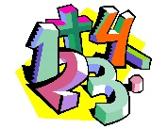  Focusing on numbers to 10. Recognising, reading and writing numbers using the correct formation. Simple addition and subtraction and explore using equipment to demonstrate their understanding. | 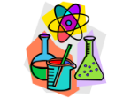  Exploring the five senses and using their investigation skills, the children will learn how we use these senses day-to-day.They will identify and name the basic parts of the human body.
History | Geography
The children will learn about how their lives are different to those within living memory. They will look at and compare toys from their grandparents’ era, having the chance to play with some. They will be introduced to the concept of a timeline. | The children will learn about their local area and the geography of the school. They will begin to learn mapping skills. They will also look at geographical resources, such as globes, maps and aerial photographs.
RE | PE
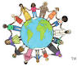  Christianity  Children will learn about Christianity and answer the question: Does God want Christians to look after the world? | Dance  Children will be exploring different ways to move their bodies and responding to a variety of stimuli. Moving expressively, confidently and safely in space. Using a variety of speed, level and direction. Children will create and repeat short dances.
Art | DT
The children will continue to use their senses to think about emotions can be show in paintings and drawings. They will use a range of drawing and painting skills to create different moods with a piece of artwork. | 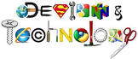  Children will learn how to cut food safely and know how fruit and vegetables are healthy.
Computers | Music
The children will develop their understanding of technology and how it can help them in their every- day lives. They will start to become familiar with the different components of a computer by developing their keyboard and mouse skills. They will also consider how to use technology responsibly. | Children will be listening to a variety of musical styles. They will be learning about how pulse, rhythm and pitch work together. They will use un-tuned instruments to practise pulse and rhythm. And they will use their voices to work on pitch and volume.
PSHE (Jigsaw)
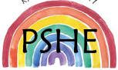
Being me in my world

Children will talk about why their class is a safe place to learn. They will give different examples of where they or others make their class safe and happy. They will begin to explain why their behaviour can have an impact on other people in their class.

