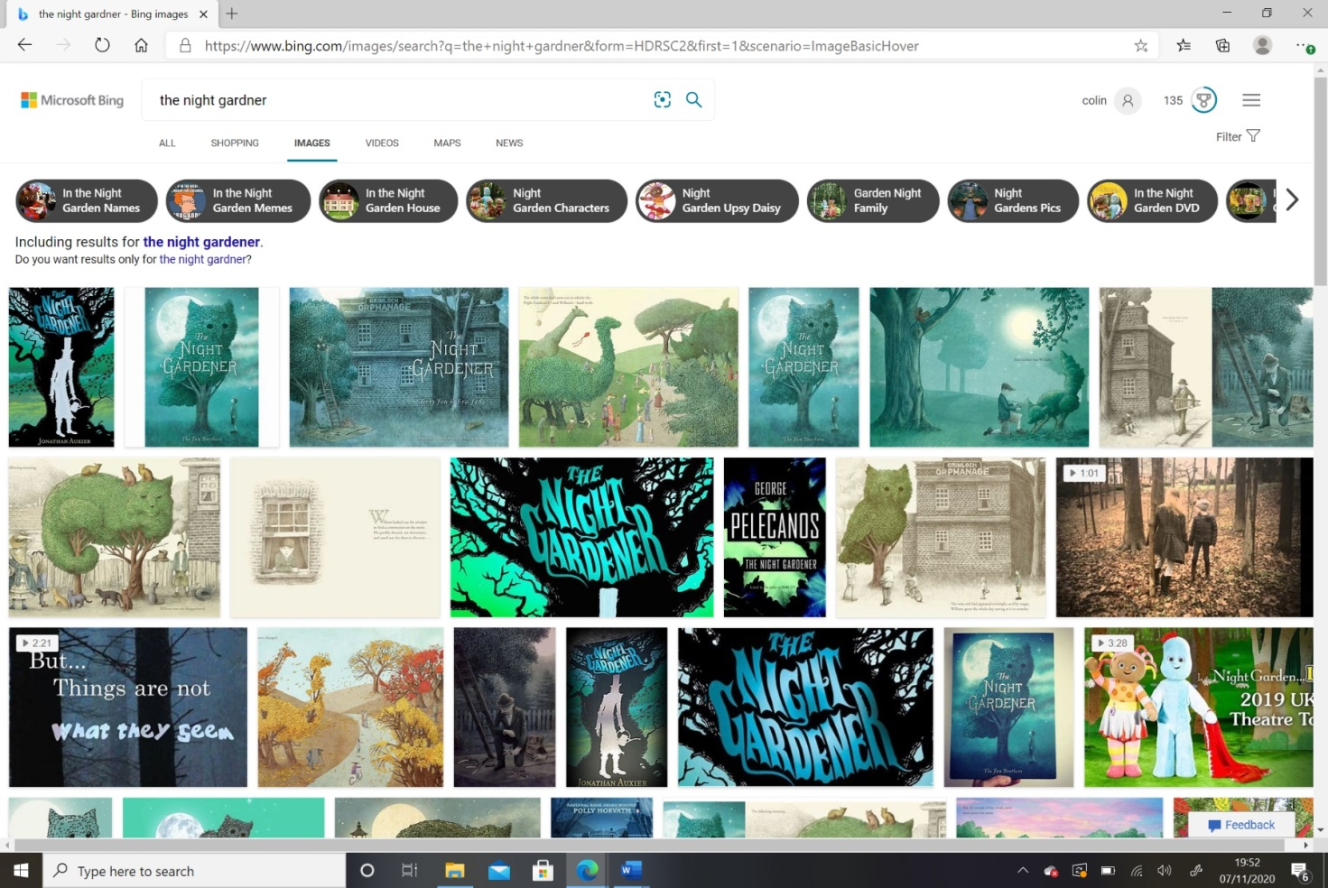

**Science**

Living, Dead or Never Alive

Life Processes:

Movement

Respiration

Sensitivity

Growth

Reproduction

Excretion

Nutrition

**Our Local Area**

While learning about how our local area has changed we will use vocabulary such as:

* Long ago
* Modern
* Timeline
* Different
* Artefact
* Change
* Old-fashioned
* Historical

**Geography**

The four capital cities of the UK are:

* London is the capital of England and is where you will find Buckingham Palace.
* Cardiff is the capital of Wales and is home to the Cardiff International Sports Stadium.
* Edinburgh is the capital of Scotland and the Royal Mile is a well-known road that runs through the city.
* Belfast is the capital of Ireland and is the birth place of the RMS Titanic.

